**ALGORITHM**

1. Start
2. Sort the array of elements
3. Compare the elements and swap if they are in wrong elements
4. If the current element is greater than the next element swap
5. Set the flag to true after swapping is completed
6. If no swaps were made the array is sorted
7. End

**PSEUDOCODE**

n = length(A)

for i from 0 to n-1

swap=false

for j from 0 to n-i-1

if A[j] > A[j+1]

swap A[j] and A[j+1]

swap=true

if swap becomes false

break

**FLOWCHART**

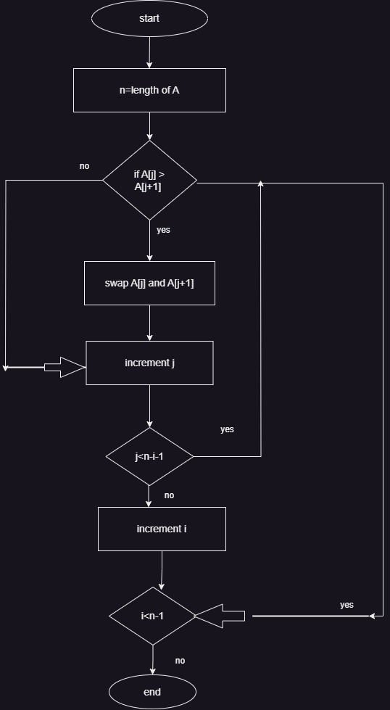

**EXPLAINATION:**

* + - * Iteration occurs throughout the array multiple times by comparing adjacent elements. While each iteration current element will be swapped if next element is greater than current element then the process will be continued till the array gets sorted.

**SIMPLE EXAMPLE OF ARRAY**

Initial Array :5,2,4,1

after 1st pass :2,4,1,5

after 2nd :2,1,4,5

after 3rd :1,2,4,5 = finally sorted array